These logos were submitted in February 2019. Be sure to check with your honors program to ensure the logo has not been updated since.

BUMPERS COLLEGE

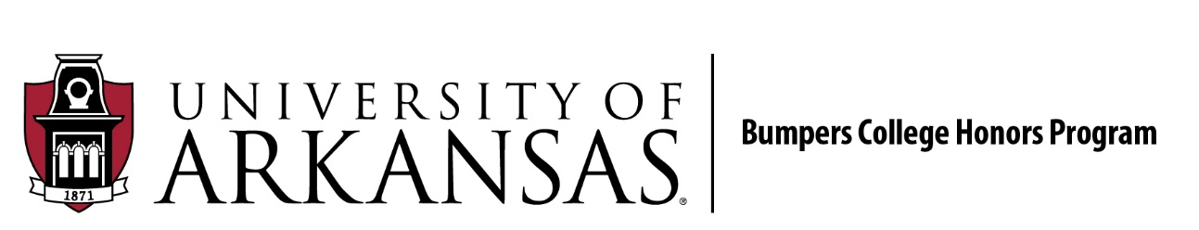

FAY JONES SCHOOL OF ARCHITECTURE AND DESIGN

FULBRIGHT COLLEGE

COLLEGE OF EDUCATION AND HEALTH PROFESSIONALS

COLLEGE OF ENGINEERING

WALTON COLLEGE OF BUSINESS

